Tutorial: 5

Name: Chalani Saumya Rajapakshe

Id: IT21377280

Exercise -01

1. A screenshot of a computer

   Description automatically generated
2. Graphical user interface, text

   Description automatically generated
3. Graphical user interface, text, application

   Description automatically generated

Exercise-02

Exercise-03

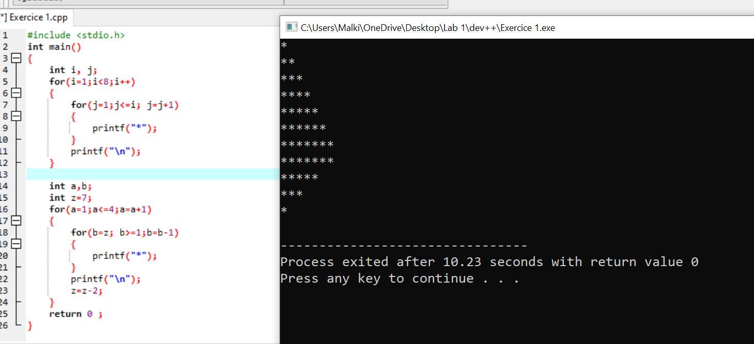Exercise-04